M. Friedl, H. Pernegger

Phobos Spectrometer
Module Tests

Phobos Collaboration Meeting
BNL, Apr 16–18, 1999

Contents

- Introduction
- Calibration and Source Test
- Calibration Details
- Module Studies
- Signal
- Noise
- Signal-to-Noise
- Summary

Introduction
- Terminology:
1 or 2 hybrid(s) + 2 to 4 sensors = 1 module
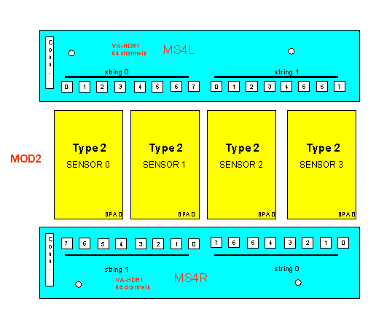
“Left”
Hybrid
“Right”
Hybrid
Silicon Sensors

- Status:
Assembly of Phobos Spectrometer finished
(42 installed modules)

Calibration and Source Test
- 2 module tests:
- Calibration (performed on all hybrids and on all modules)

DAQ
Voltage
Step
Generator

Calibration
Capacitor
VA-HDR1

Detector
Capacitance
- Source Test (performed on final modules)

VA-HDR1
DAQ
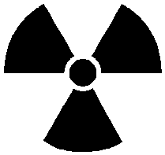
⁹⁰Sr source
Si
Sensor
Trigger
Scintillator
Source particle

- Why calibration?
- Testing, immediately repairing bad bond wires etc. before any further assembly step
- Obtaining gain (calibration) of every single channel (spectrometer including spares: 68k)
- Find defect and noisy channels

- Why source test?
- Final module test, similar to beam operation
- Study module properties
- Determine signal and signal-to-noise

Measured data is filled into the Assembly Database (accessible via Phobos Web pages)

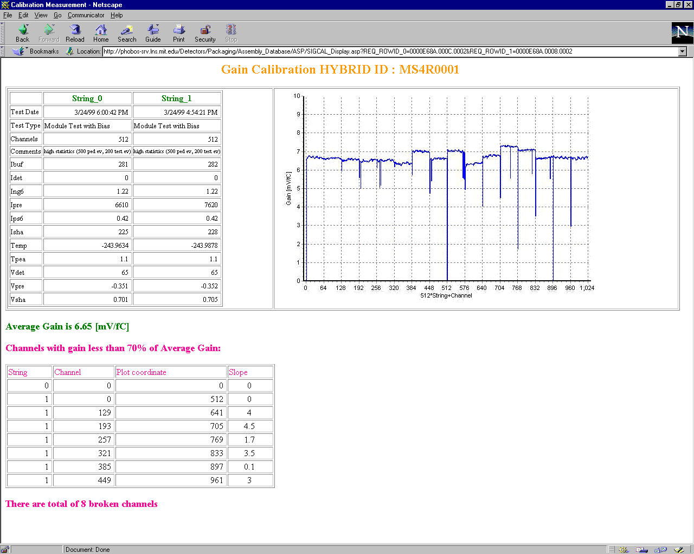

Calibration Details
- Step pulse over capacitor
- ΔQ = C ΔV
- Ex.: 1 mV on 2 pF gives 12500 e⁻
- Design considerations to minimize noise

- Output parameter: Channel gain [mV/fC]

- Calibration test setup
- Hybrid/Module
- Adapter board with step DAC and pulse generator board (E. Griesmayer, H. Frais-Kölbl), range 0..350 fC, diff. lin. better than 1%
- CERN Repeater cards (A. Rudge)
- NIM sequencer logic
- National Instruments ADC board
- PC running LabView

- Calibration components
- 1 capacitor is located close to each VA chip on the hybrids
- Switching logic is integrated in the VA chips

- Gain Uniformity
- Within 1 chip: <3% pp
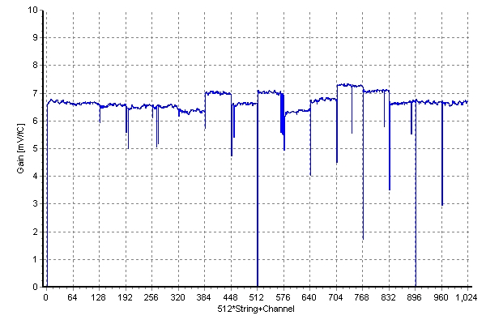

- Chip-to-chip: <15% pp
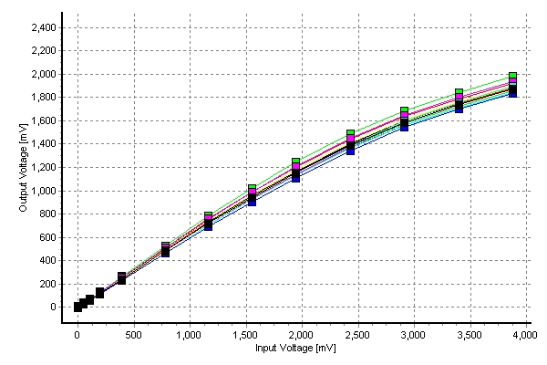

- Calibration allows to indentify
- good channels
- pinholes
- channel shorts

- Calibration modes
- “Standard”: done on every hybrid and module, running for about 6 months
- “Precision”: done on selected modules, special effort on stability and parameter settings, done for module properties measurements (running for a few days)

- Calibration repeatability
- Standard: <3% (no effort to maintain voltages like FEC)
- Precision: <1% (as expected with FEC)

- No charge loss due to detector capacitance
- Could be calculated from calibrations of hybrid (w/o sensor) and module (w/ sensor) to see large effects >10%
- Detector capacitance: 25 pF (typ.)
- VA input capacitance: not measured
- Charge loss below standard mode error
→ VA input C >> detector C

- Sample gain map for MOD20001

- Comparison of average chip signals without and with channel calibration

Module Studies
- Levels of study
- Single sensor level
- Single module level
- Module/sensor comparison level

- Typical example: MOD20001
- 4 sensors (thicknesses 308..310 μm)
- 5 rows, 400 columns
Origin
Corner
Columns
Rows

- Sensor level
- Sensor signal distribution (norm. to 300μm)

- Fit function: Landau convoluted with Gaussian

3 parameters:

Width, MP, Area
1 parameter:
Sigma

- Gaussian sigma represents electronic noise and intrinsic detector fluctuations, typically about 2x electronic noise

- Peak of convolute is slightly shifted from pure Landau peak (MP)

- Sensor RMS noise map

- Sensor MP signal vs. row

- Module level
- Signal and SNR distributions (norm. to 300μm)

MP = 21523 e⁻ = 77.9 keV

SNR = 16.4

- Relative MP signal vs. row

Uniformity better than 1% pp !!!

Signal
- Absolute MP signal vs. sensor type (normalized to 300 μm thickness)
- Acquired with ⁹⁰Sr β source
- Average source signal: 21081 e⁻
- Signal range: 20119..21552 e⁻
- Signal MP agrees with capacitive loss calculation (charge sharing between detector and VA input capacities)

- Relative MP signal vs. row
- Uniformity: <1%
- Very uniform even though readout lines vary in length (3..65 mm)

- Mystery
- 3% (1% at testbeam) difference between front and back half of hybrids
- Intrinsic module property, reason: ?
- We can exclude external effects because:
- Calibration and source tests are done with the same set of repeater boards
- Switching the ADC channels does not change anything
- Same (though smaller) effect in testbeam with totally different DAQ hard- and software

Noise
- Single channel physical connections

R_{P}
Sensor
+HV
- Single channel preamp noise model

R_{P}
R_{S}
I_{Leak}
T_{P}
ENC_{C}
C
symbol | represents | typ. value
I_{Leak} | Fraction of sensor leakage current | 5 nA
R_{P} | Parallel resistance (polysilicon) | 2 MΩ
C | Capacitance of pad against backplane, between pads and between metal 1 and metal 2 layers | 25 pF
R_{S} | Effective serial trace resistance | 40 Ω
T_{P} | Shaper peaking time | 1.2 μs
ENC_{C} | Preamp noise (k + C · d) | 950+5/pF e⁻

- Total preamp equivalent noise charge
$${\text{ENC}}^{2}={\text{ENC}}_{C^{2}}+{\text{ENC}}_{{\text{ILeak}}^{2}}+{\text{ENC}}_{{\text{RP}}^{2}}+{\text{ENC}}_{{\text{RS}}^{2}}$$

- Contributions
$${\text{ENC}}_{C}=k+C d$$
$${\text{ENC}}_{\text{ILeak}}=\text{106}\sqrt{I_{\text{Leak}} T_{P}}$$
$${\text{ENC}}_{\text{RP}}=\text{758}\sqrt{\frac{T_{P}}{R_{P}}}$$
$${\text{ENC}}_{\text{RS}}=0\text{.}\text{395} C\sqrt{\frac{R_{S}}{T_{P}}}$$

with ENC [e⁻], k [e⁻], d [e⁻/pF],
I_{Leak} [nA], T_{P} [μs], R_{P} [MΩ], R_{S} [Ω]

- Preamp noise with typical values (as stated above)
ENC_{C} = | 1078 | e⁻
ENC_{ILeak} = | 249 | e⁻
ENC_{RP} = | 562 | e⁻
ENC_{RS} = | 60 | e⁻
ENC = | 1243 | e⁻

- Shaper/Buffer and readout noise adds to preamp noise
- Estimated shaper/buffer noise: 100 e⁻
- Measured test setup readout noise: 450 e⁻

- Calculated and measured noise vs. sensor type

- Calculation and measurement agree very well
- Measured RMS noise:
- Average noise: 1383 e⁻
- Noise range: 1230..1517 e⁻

Signal-to-Noise
- SNR vs. Sensor Type (normalized to 300 μm)

- Measured SNR:
- Average SNR: 15.2
- SNR range: 14.4..16.9

Summary
- Stable calibration and source test setups
- Gain of every single channel written into assembly database
- Gain uniformity:
<3% pp within chip, <15% pp chip-to-chip
- Calibration repeatability during tests
<1% precision

- Gain before and after sensor mounting is the same within error bars
- No significant charge loss by detector capacitance
- Due to large VA input capacitance

- Mystery
- 3% signal difference between hybrid halves

- “The general picture”
- Landau-Gaussian convolute fit function
- Typ. values (MOD20001):
- MP signal (⁹⁰Sr source) = 21500 e⁻
- RMS noise = 1347 e⁻
- SNR = 16.0

The sensor properties:
- Signal (normalized to 300 μm thickness)
- Average MP signal: 21081 e⁻
- Signal range: 20119..21552 e⁻
(depending on sensor type)
- Uniformity: Signal vs. row <1% on all sensor types → very uniform!!!

- Noise
- Primarily depends on detector capacitance
- Average RMS noise: 1383 e⁻
- Noise range: 1230..1517 e⁻
(depending on sensor type)
- Agrees very well with model

- Signal-to-noise (normalized to 300 μm thickness)
- Average SNR: 15.2
- SNR range: 14.4..16.9
(depending on sensor type)

P. Shulek et al., Sov. J. Nucl. Phys. 4, 400 (1967)

