Phobos Note #10-98
August 25, 1998

Calibration of the Phobos Silicon Detectors

E.Griesmayer, H.Frais-Kölbl, Fachhochschule Wiener Neustadt, AUSTRIA
J.Fitch, H.Pernegger, B.Wadsworth, MIT, USA

MIT, Massachusetts Institute of Technology
Laboratory for Nuclear Science

Abstract
The Phobos silicon detector requires calibration of up to 100 MIPs. This corresponds to a calibration charge of 400 pC. The relative linearity of the calibration circuit has to be better than ±1% over a dynamic range of 1:400. The calibration circuit should be able to drive a low-impedance load of 50 Ω. The rise time of the calibration pulse must be less than 50 ns. A prototype of a calibration circuit was tested in the lab with a type-4 silicon detector. Backplane calibration for a common test of all detector channels was tested as well.

The calibration scheme

The calibration circuit uses a 12-bit DAC as voltage reference and a fast switch, which is controlled by a digital calibration sync signal. A 50 Ω resistor is used for back termination. After the cable there is a voltage divider and the calibration capacitance C_{cal} = 2 pF.
DAC
Calibration Sync
50 Ω
1 kΩ
C_{cal} = 2 pF
Preamplifier
50 Ω
Cable
Q_{cal}
Buffer
u_{DAC}
u_{cal}
12
DAC_count
Calibration circuit

Figure 1: Schematic of the calibration circuit.

The calibration charge Q_{cal} is injected into the preamplifier:

$Q_{\text{cal}}=C_{\text{cal}}⋅\left(u_{2}−u_{1}\right)$.

The voltage difference u₂ – u₁ is provided by switching a DAC voltage u_{DAC}, which can be adjusted by setting the DAC with an integer value DAC_count. The value of DAC_count can vary between 0 and 4095. The DAC voltage is reduced due to the back-termination resistor on the calibration board:

$u_{\text{cal}}=u_{\text{DAC}}⋅\frac{\text{1050}Ω}{\text{1050}Ω+\text{50}Ω}=0\text{.}\text{9545}⋅u_{\text{DAC}}$,

giving the calibration voltage u_{cal}. The calibration voltage is further reduced by a voltage divider at the input of the preamplifier by a factor of:

$\frac{\text{50}Ω}{\text{1000}Ω+\text{50}Ω}=1:\text{21}=0\text{.}\text{0476}$.

The calibration capacitance converts the calibration voltage into the calibration charge Q_{cal}:
$Q_{\text{cal}}=C_{\text{cal}}⋅u_{\text{DAC}}⋅\frac{0\text{.}\text{9549}}{\text{21}}$.
The maximum calibration charge Q_{cal,max} is given at full DAC voltage by:

$Q_{\text{cal}\text{,max}}=2 \text{pF}⋅\text{4095} \text{mV}⋅\frac{0\text{.}\text{9549}}{\text{21}}=\text{372}\text{.}4 \text{fC}$.

The preamplifier response to the calibration pulse is independent of the rise time of the calibration pulse, provided it is somewhat shorter than the rise time of the preamplifier. The rise time of the preamplifier is estimated with 400 ns. The pulse width of the calibration pulse was specified with <50 ns.

Measurements

The measurements were performed with a VA128-HDR1 chip mounted on a type 4 detector. Every second channel on the chip was connected to a detector pad. The detector was biased with V_{bias} = +60 V during the measurements. The chip was operated at V_{fp} = –330 mV, V_{fs} = +630 mV, I_{pre} = 450 μΑ, I_{sh} = 14.4 μA and I_{buf} = 126 μΑ.

A calibration pulse is shown in Figure 2. Its amplitude is 2.0 V, for a DAC setting of 2048. The rise time of the calibration pulse is about 23 ns. The buffer offset voltage of 100 mV was not compensated.

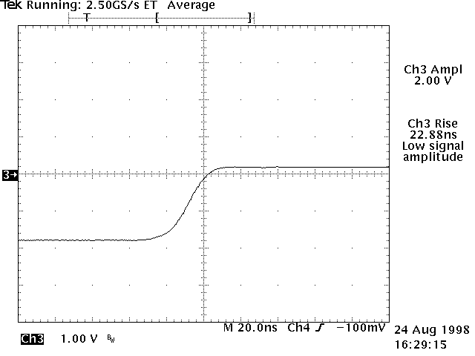

Figure 2: Calibration pulse u_{cal} for DAC_count = 2048;
(average of 16 pulses; 20 MHz filter).
A preamplifier response is shown in Figure 3. It has a pulseheight of 700 mV for DAC_count = 2048 and a peaking time of 1.2 μs. The rise time is 664 ns and the fall time 2.76 μs.

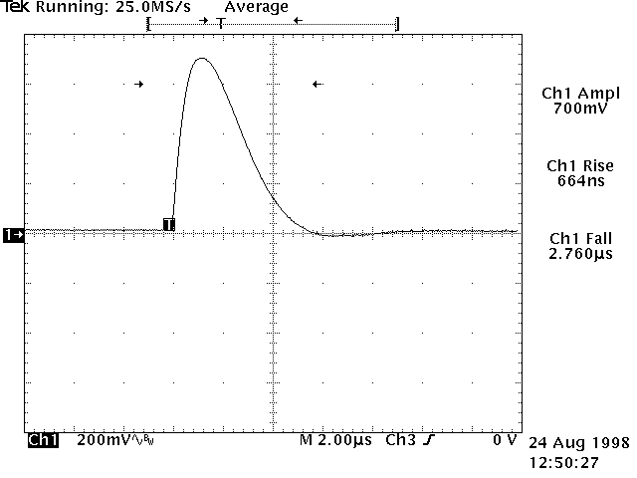

Figure 3: Preamplifier output for DAC_count =2048.

The delay between the calibration sync signal and the calibration pulse is 180 ns. The delay between the calibration pulse and the preamplifier output is 100 ns. The peaking time of the preamplifier output is 1.2 μs (see Figure 4). The total delay between calibration sync and the peak of the preamplifier output is 1.48 μs.
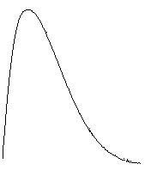
Calibration sync
Calibration pulse
Preamplifier output
100 ns
1.2 μs
180 ns

–5 V

u_{cal}

Figure 4: Timing of a calibration sequence.

Calibration linearity

The linearity of the calibration system was measured over a dynamic range of 1:256, DAC_count from 16 to 4095. A limitation was given by the 5 mVrms noise of the system. The linearity of the calibration system was determined by a straight-line fit resulting in the linear calibration function u_{cal,lin} with two parameters k and d:

$u_{\text{cal},\text{lin}}=k⋅\text{DAC_count}+d$.

The linearity of the calibration system is shown in Figure 5, where it is compared to a straight line.

Figure 5: Linearity of the calibration system
measured over a dynamic range of 1:256.

The parameter k is given in mV and corresponds to the slope of the straight line. The parameter d is given in mV and corresponds to the offset voltage of the calibration circuit. The fitting procedure resulted in:

$k=0\text{.}\text{9707} \text{mV}$,

and $d=0\text{.}\text{00014} \text{mV}$.

There is a difference of 1.70% in the slope between the measurement and the calculated value.
The conversion of the linearized calibration voltage to the linearized calibration charge Q_{cal,lin} is given by:

$Q_{\text{cal},\text{lin}}=C_{\text{cal}}⋅u_{\text{cal},\text{lin}}⋅\frac{1}{\text{21}}$,

which results in a maximum linearized calibration charge of

$Q_{\text{cal},\text{lin}\text{,max}}=\text{378}\text{.}6 \text{fC}$.

The absolute deviation of the calibration system from the straight line, $u_{\text{DAC}}−u_{\text{cal},\text{lin}}$, is less than ±2 LSB over a dynamic range of 1:256. The relative linearity of the calibration system,$(u_{\text{DAC}}−u_{\text{cal},\text{lin}})/u_{\text{cal},\text{lin}}$, is better than ±1% over the full dynamic range.

Figure 6: Relative nonlinearity of the calibration system
measured over a dynamic range of 1:256.

Detector linearity

The linearity of a type 4 detector was determined with the calibration board. The DAC_count was changed from 0 to 4000 in steps of 100. The detector response was measured with the data acquisition system. The Figure 7 shows the linearity of 10 detector channels.

Figure 7: Linearity of 10 detector channels measured with the calibration board;
type 4 detector, channel #1 to #10, V_{bias} = 60 V.

The linearization of the detector was not performed for these tests. The pulseheight is about double as compared to previous measurements with the scope. This is due to the bipolar setup in the data acquisition system.

Backplane calibration

Charge is injected into the backplane of the detector via a 15 nF/100 V coupling capacitance. All detector channels are pulsed synchronously. This mode of operation allows for an effective common test of the whole detector.

50 Ω
15 nF/100 V
Backplane
Cable
+60 V
10 kΩ
4.7 nF
DAC
Calibration Sync
Buffer
Calibration circuit
12
DAC_count

Figure 8: Schematic of the backplane calibration.

The preamplifier response was 356 mV to a 32 mV backplane voltage step. From the 128 preamplifier channels, 64 were connected to the detector. The remaining 64 preamplifier channels were not connected to the detector. These channels showed nevertheless signals (see Figure 9). This might be due to the strong load in the current supply of the preamplifier chip in this operational mode.

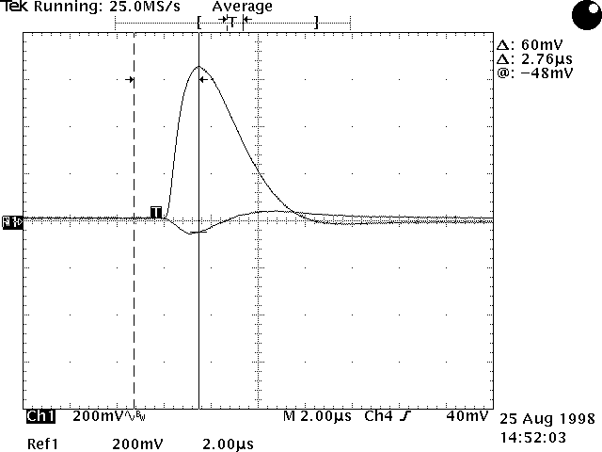
11%
Detector not connected to preamplifier

Figure 9: Preamplifier response to a backplane signal.
The amplitude of the coupled signal is 11% at the maximum of the original preamplifier output. The propagation time of the single-channel signal is 280 ns less than that of the backplane signal.

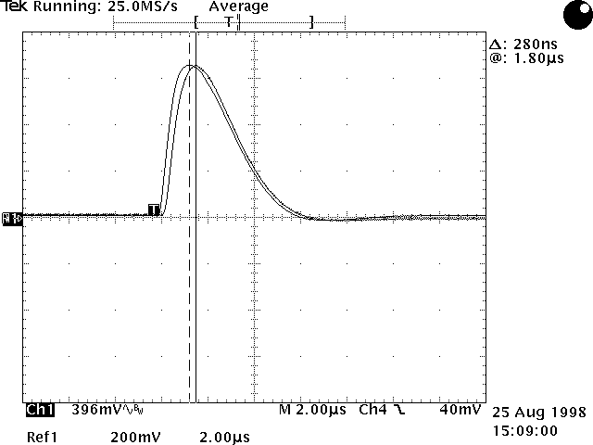
Single channel
Backplane

Figure 10: Preamplifier output to backplane and single-channel calibration;
the difference in propagation delay is 280 ns.

Detector uniformity

The uniformity of the detector cells was measured by applying a calibration voltage of 4 V. The response of 128 channels was measured and plotted versus the channel number.

Drop = 4%
Figure 11: Uniformity of the response of 128 detector channels. There is a 4% drop of the
output signal (measured with a calibration voltage of 4 V).

There is a systematic drop of the preamplifier output towards higher channel numbers of about 4%. This might be due to different preamplifier gains caused by a voltage drop inside the chip or due to different transition times inside the chip.

Conclusion

The calibration circuit of the Phobos silicon detectors allows calibration over a dynamic range of 1:400. The measured full-scale calibration charge was 378.6 pC. The linearity of the calibration circuit was better than ±1% in a dynamic range of 1:256. The rise time of the calibration voltage step is below 25 ns. The detector channels show a drop in uniformity of 4%. A backplane calibration mode allows a synchronous test of all detector channels. We measured crosstalk of 11% in this mode.
The calibration board is a two-layer printed circuit board using SMD components. The calibration boards are part of the front-end readout controller (FEC). Each FEC will be equipped with four calibration boards. In total there will be 51 FEC and 204 calibration boards.
Appendix A: The calibration circuit

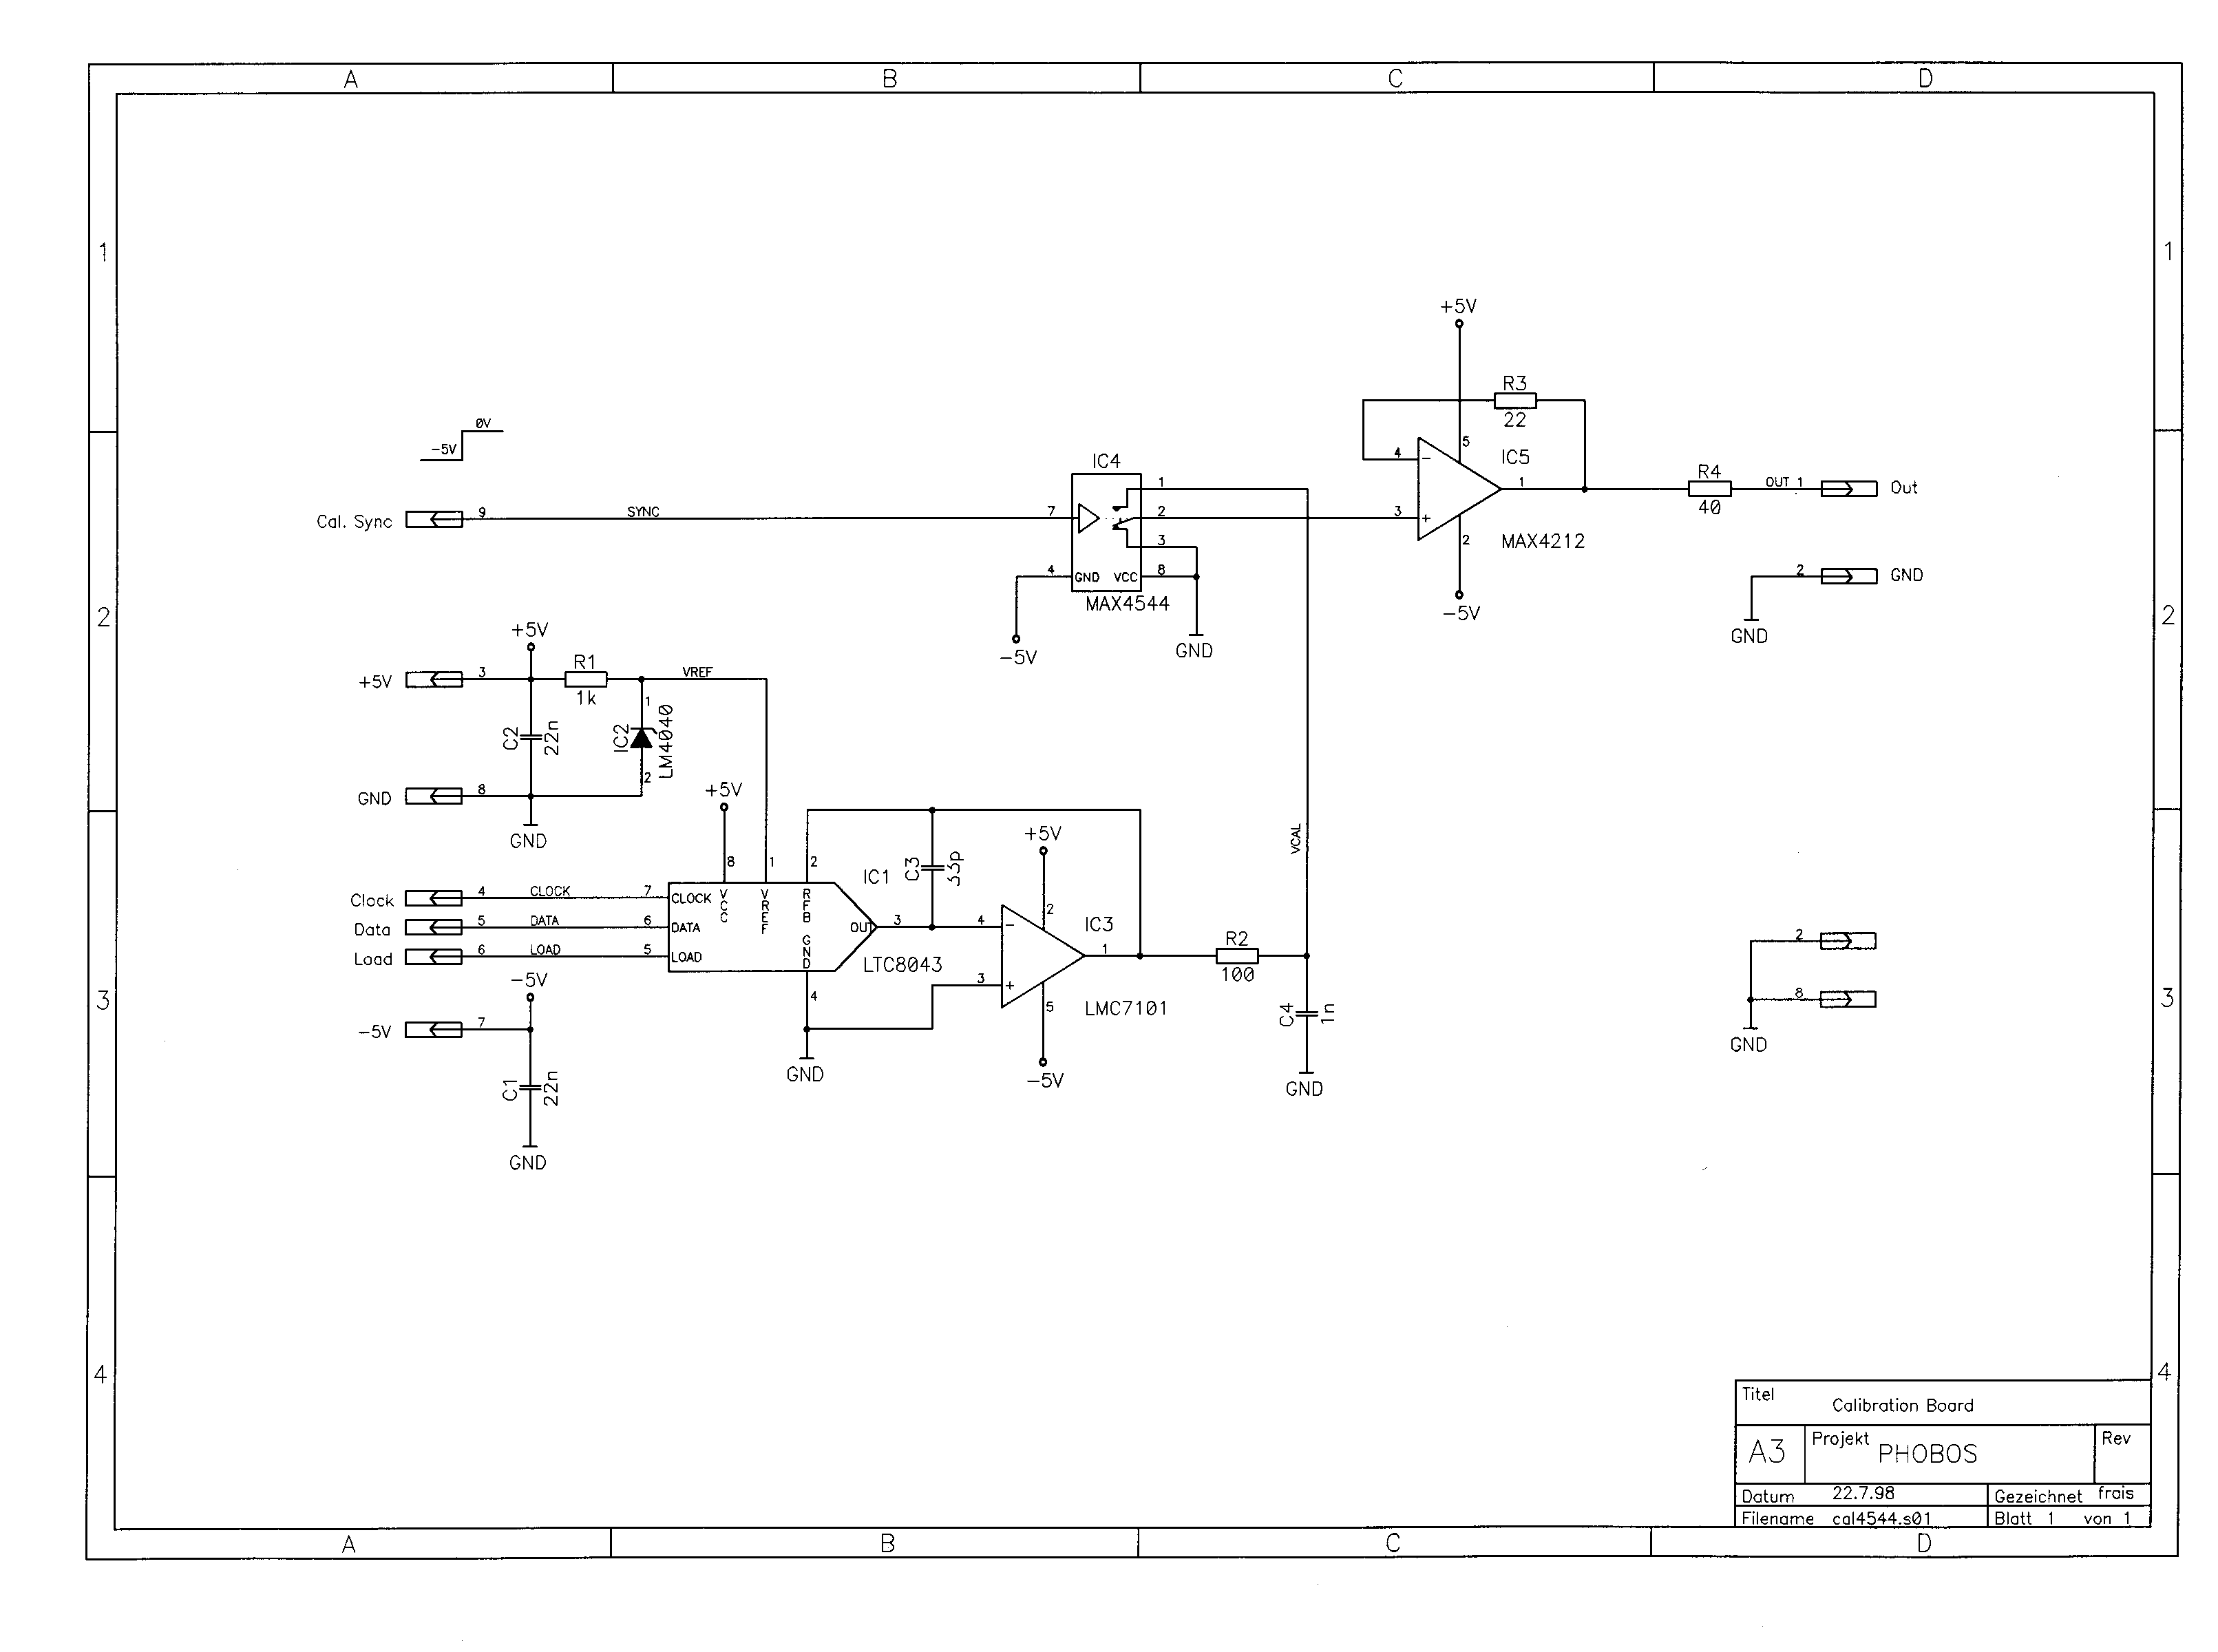
Figure 12: Circuit diagram of the calibration circuit .

Appendix B: The layout of the calibration PCB

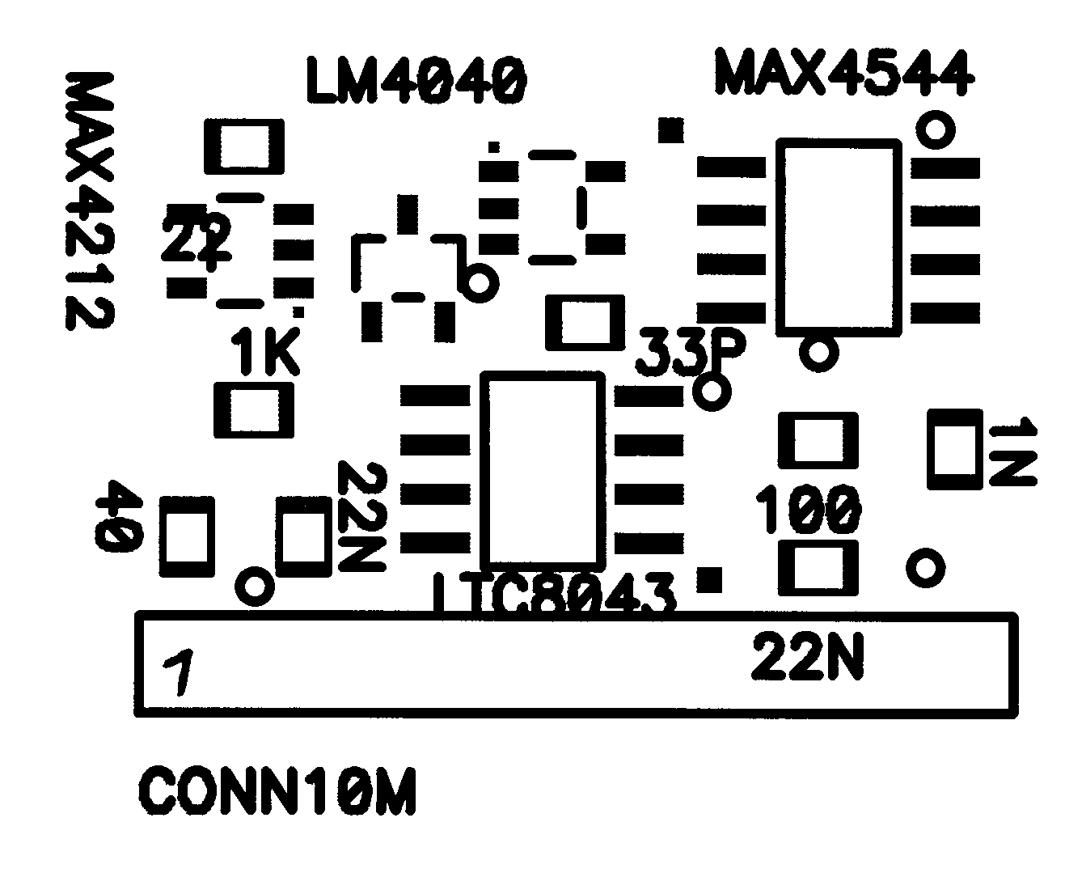
25 mm
19 mm

Figure 13: Layout of the calibration board PCB.

Appendix C: Pin layout

Pin # | Signal
1 | Calbration voltage, u_{cal}
2 | GND
3 | +5 V
4 | Clock
5 | Serial data
6 | Load
7 | –5 V
8 | GND
9 | Calibration sync
Table 1: Pin layout of the calibration board.

Appendix D: List of components

There are 13 components and 9 connector pins.

Component | Company | Component number | # | Reference
DAC | Linear Technology | LTC8043FS8 | 1 | IC1
Voltage reference | National | LM4040DIM3-4.1 | 1 | IC2
I/U converter | National | LMC7111BIM5X | 1 | IC3
Analog Switch | Maxim | MAX4544CSA | 1 | IC4
Buffer | Maxim | 4212EUK | 1 | IC5
Resistor |  | 1kΩ | 1 | R1
Resistor |  | 100Ω | 1 | R2
Resistor |  | 22Ω | 1 | R3
Resistor |  | 50Ω @ 1% | 1 | R4
Capacitor |  | 100nF | 2 | C1, C2
Capacitor |  | 33pF | 1 | C3
Capacitor |  | 1nF | 1 | C4
Connector pins |  |  | 9 | K1
Table 2: List of components.

Appendix E: Further considerations

- Noise
There was high baseline noise (5 mVrms when measured with 20 MHz bandwidth limitation and 20 mVrms without). This was partly due to the radio station close to MIT. This effect is known. But there was additional noise, which seemed to be coupled to the switching of the calibration board. This noise is synchronous to the calibration synch signal and is correlated to the length of the cable. This effect should be studied in a further detail.

- Termination
We measured the signal at the monitoring output. There is a significant undershoot, when measured into 50 Ω. The undershoot disappears, when the measured into 1 MΩ. This effect has to be studied.

- Power supplies and cabling
We have observed that the noise of the system is very sensitive to switching transients on the supply lines. Decoupling of the power lines is an important parameter. The stability of the power supplies should be checked after the installation of the detector.

- Timing of the DAC and I/U converter setting
The small slew rate of the I/U converter requires a minimum time delay of 400 μs between the DAC setting and the calibration sync signal.

* * *

Measurements were done with a Tektronix TDS 540 digital oscilloscope.
A LMC7111 was used instead of LMC7101, R4 = 50 Ω. Changes during the test: C1 = C2 = 100 nF. Changes after the tests: Pin 1 and pin 3 of IC4 must be exchanged; R4 must be chosen according to the impedance of the Kapton cable.

