BRAHMS MRS Threshold Cherenkov Proposal
R. Debbe, H. Ito, M. Murray, J. Norris and S. J. Sanders

The principal physics goal of the BRAHMS experiment is to explore the dynamics of relativistic heavy-ion reactions and the properties of the highly excited nuclear states formed in these reaction. This is done by measuring spectra of identified particles over a broad range of pseudorapidity and transverse momentum using two magnetic spectrometer arms, one for measuring spectra at forward angles corresponding to the fragmentation region of the reaction, and the second for measuring spectra a mid-rapidity. The high transverse momentum part of the spectrum, with p_{t}>2 GeV, is particularly important to study since this is the range where the influence of partonic processes are most likely to be seen¹. Indeed, evidence has been presented for data of a reduction in the number of hadrons at high transverse momentum near mid-rapidity, thus hinting at a suppression of hadronic jets at high matter densities^{2, 3}. Unfortunately, the BRAHMS experiment is currently limited in the range for which particles can be identified at mid-rapidity by the fundamental limitation that the speed of light imposes on the time-of-flight system used for particle identification at these angles.

The overall layout of the BRAHMS experiment is shown in Fig. 1. With the two spectrometer arms, labeled as the Forward Spectrometer (FS) and Mid-Rapidity Spectrometer (MRS) in Fig. 1, we obtain an acceptance plot for identified pions as shown in Fig. 2. Particle identification is accomplished in the forward spectrometer by either time-of-flight measurement (H1, H2) or by Cherenkov radiation detection (C1, RICH), with high momentum particles identified using the ring-imaging Cherenkov detector at the end of the FS (RICH). The MRS relies on time-of-flight measurement for particle identification (TOFW), leading to a restricted range in transverse momentum for which identification is possible and preventing us from accumulating spectra of “hard” scattering processes with good particle identification.
Fig. 1 — Experimental layout of BRAHMS.
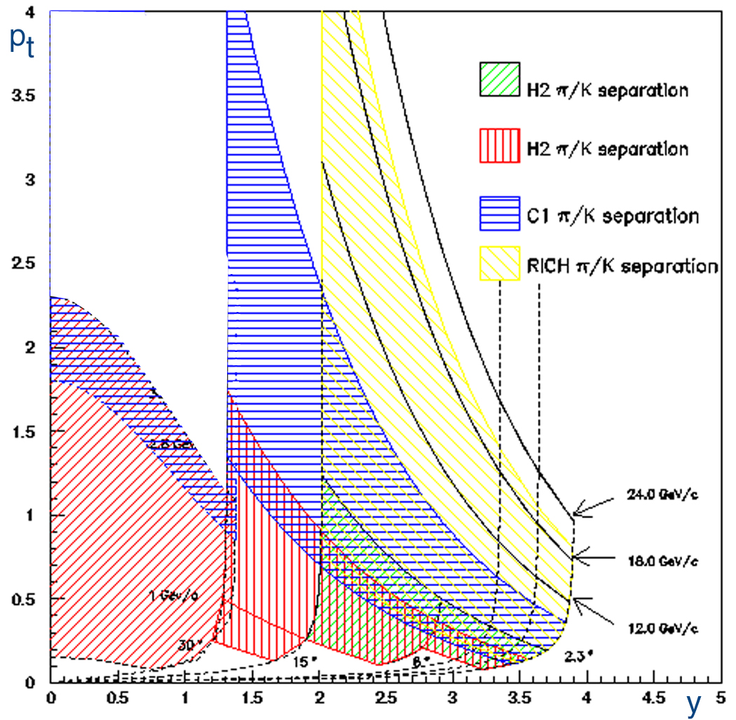
Fig. 2—Current acceptance plot of BRAHMS for π/Κ separation.
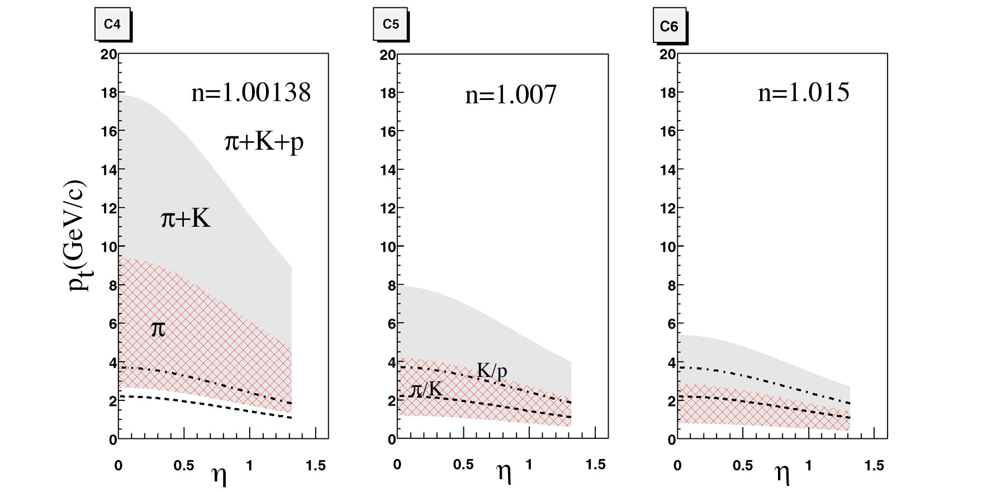
Fig. 4—Particle identification regions for the C4, C5, and C6 threshold Cherenkov detectors. The bottom of the cross hatched region marks the Cherenkov threshold for pions. The top of this region is the kaon threshold, and the top of the solid fill region is the proton threshold. Also shown by the dashed and dot-dashed curves are the limits where π/K and K/p identification can be achieved using the TOFW.
We have been exploring what we believe will be a highly cost effective program to significantly extend the p_{t} range at mid-rapidity where we can achieve particle ID. The layout that is currently being considered is shown in Fig. 3. A gas threshold Cherenkov counter (C4) will be located immediately behind the time-of-flight wall (TOFW) of the mid- rapidity spectrometer. This counter will be backed by two additional threshold Cherenkov counters (C5 and C6) using Aerogel radiators of increasing refraction indices. The full angular acceptance of the mid-rapidity spectrometer is preserved. Fig. 4 shows the transverse momentum thresholds for Cherenkov radiation as a function of pseudorapidity for pions, kaons, and protons in the three Cherenkov volumes. The lower edge of the cross hatched regions indicate the threshold for Cherenkov radiation for pions. The upper edge of this region is the kaon threshold and the upper edge of the solid filled region indicates the proton threshold. For each of the three volumes we also indicate the highest p_{t} value for which π/K (lower, dashed lines) separation and K/p (upper, dash-dot lines) can be achieved using the TOFW.
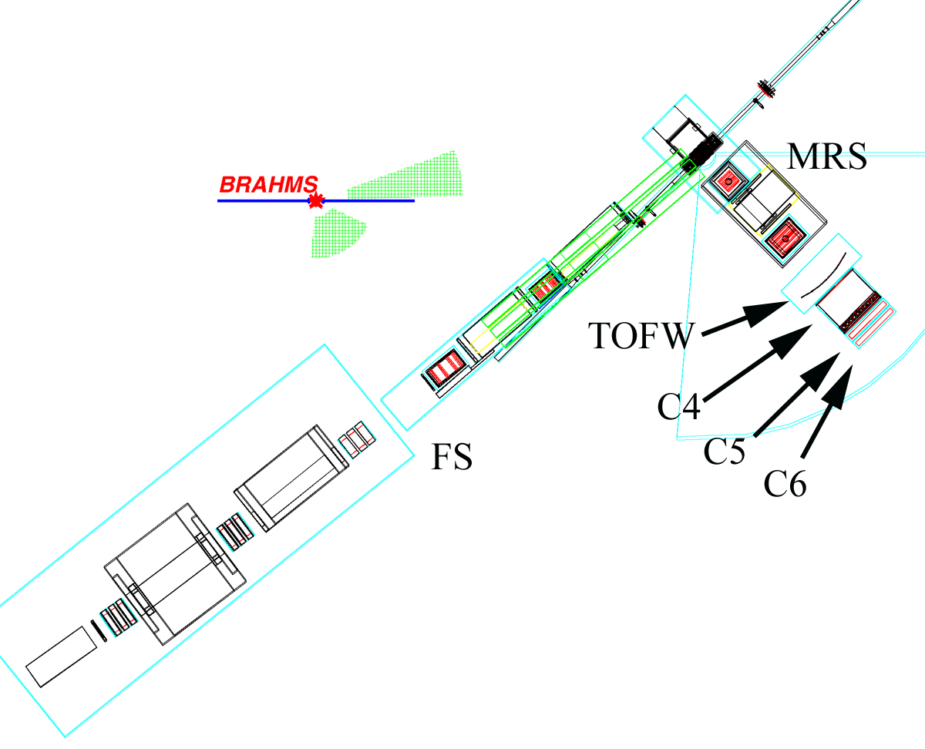
Fig. 3—Proposed layout of new Cherenkov elements (C4-C6) at the back of the MRS. The existing TPFW is also labeled.

With this arrangement it should be possible to achieve unambiguous π and kaon identification up to the Κ threshold in the first, C4, gas volume. For lower p_{t} values, time-of-flight identification is used. Once π/K identification is no longer possible using time-of-flight, the presence of Cherenkov radiation for the pions and lack of the radiation for the kaons and protons in the C5 volume is used together with the TOFW for π/K/p identification up to the point where K/p separation can no longer be achieved with the TOFW. From this point up to the C5 proton threshold, π /Κ separation is achieved, with the absence of a signal in C4 and corresponding presence of a signal in first C6 and then C5 signifying a kaon. In this range, the absence of a signal in C4 and C5 (or C6 at the low end of the range) would signify a proton. Although it will not be possible to separate pions from kaons above the C4 kaon threshold, it should be possible to separate protons from the lighter pions and kaons up to the proton threshold in C4. It will not be possible to separate kaons and protons in the limited range between the C5 proton threshold and the C4 kaon threshold.

Table 1 shows whether and how particle identification can be achieved for different ranges of transverse momentum at mid-rapidity. In each case, the primary detector for achieving π/K and K/p identification is indicated. Figure 5 shows schematically the identification coverage with all three detectors, and also in a configuration with only the C4 and C5 detectors. It can be noted that without C6 there is a gap in the K/p separation near 4 GeV/c. Since this is the maximum momentum for which we can reasonably expect to extend the particle spectra, this gap is likely to be significant when considering the physics program.
Table 1. Pariticle identification at mid-rapidity. For each range in pseudorapidity it is indicated whether or not π/K and K/p separation is possible. The primary detector needed to achieve the identification is given in parentheses.
P_{t}(GeV/c) | π/Κ | K/p
 |  | Y(TOF)
2.0-2.5 | Y(C5) | Y(TOF)
2.5-3.8 | Y(C5) | Y(TOF)
3.8-4.2 | Y(C4) | Y(C6)
4.2-5.5 | Y(C4) | Y(C5)
5.5-8.0 | Y(C4) | Y(C5)
8.0-9.5 | Y(C4) | N
9.5-18.0 | N | Y(C4)

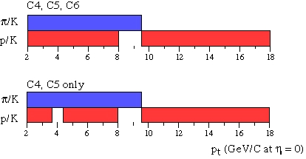
Fig. 5 —Color bars indicate ranges for which particle separation can be achieved at mid-rapidity. Two different detector configurations are indicated.

Fig. 6 shows a possible design for the C4 gas Cherenkov volume that has been incorporated into GEANT for more extensive simulations. Of particular interest are the background yields in the detector. Based on simulations using the HIJING event generator for central Au+Au collisions at we find a background rate of pions in the Cherenkov volume with tracks directed towards the mirrors of about 60% the expected primary rate. Most of these particles, of course, will not have valid tracking through the MRS. With the segmentation shown in Fig. 6, the probability of an electron or positron causing Cherenkov light in a given phototube is ~0.7% per event. Fig. 7 shows a simulation for the expected number of photoelectrons within a typical phototube frequency bandwidth (350 nm – 550 nm) as a function of momentum for pions emitted in a one degree range about 90º with respect to the beam axis. A quantum efficiency of 20% is assumed. A 90% reflectivity of the mirrors is also assumed. The design shown in Fig. 5 is such that the detector box can be constructed in the Kansas shops, allowing for a significant cost savings. Moreover, the phototubes that would be used in this design are already available at BNL. Smaller phototubes may also be available at BNL, so it may be possible to increase the segmentation, thus helping with the electron background, without significantly increasing the cost. Further study is also needed to decide on an optimal depth for the C4 detector. It is expected that the Aerogel detectors, C5 and C6, will be designed and tested at BNL and Texas A&M University. Assuming collaboration support, the construction of the MRS Cherenkov detectors should be completed well before the beginning of the next period of RHIC running in late 2002.
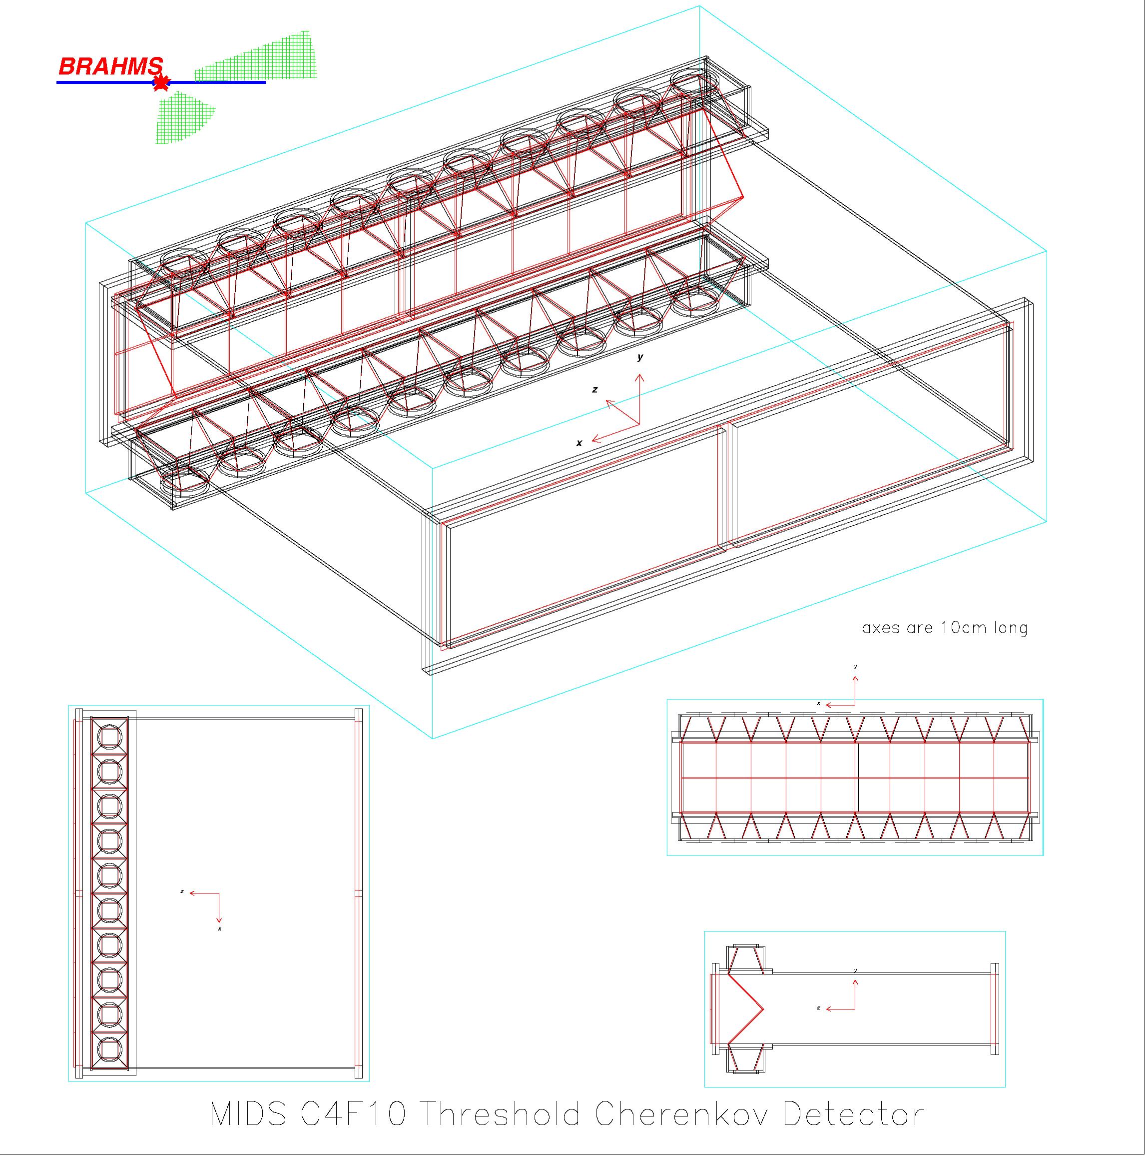
Fig. 6—Initial design study for C4 threshold Cherenkov detector.
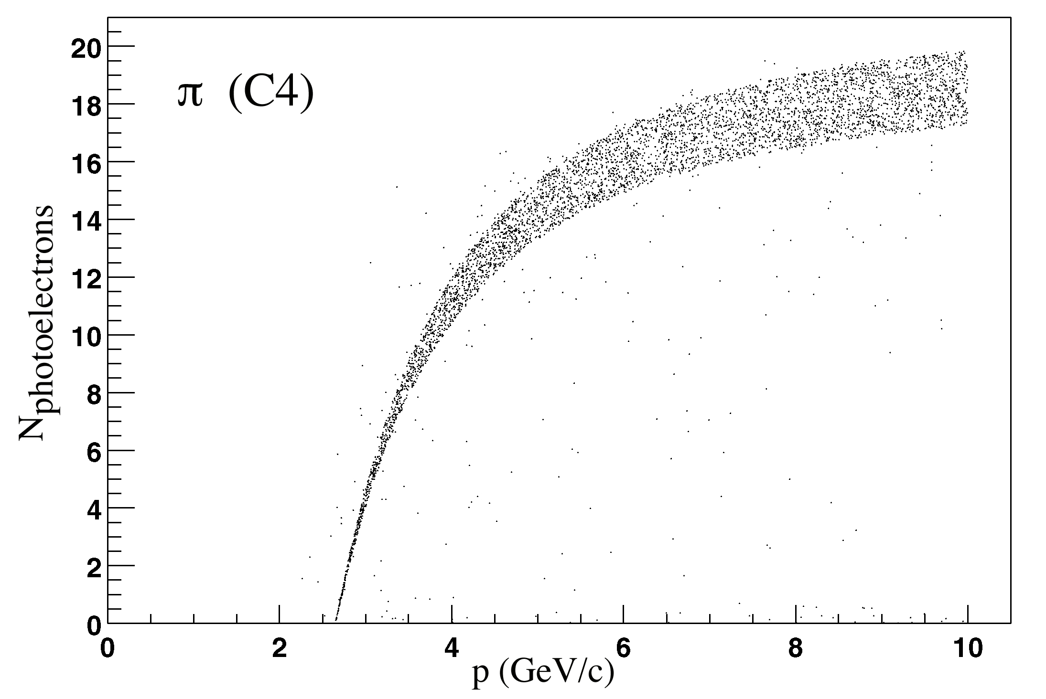

Fig. 7 —Predicted number photoelectrons in the C4 detector. The simulation is for pions emitted within a 1º angular range about 90º with respect to the beam axis

The overall cost of a mid-rapidity Cherenkov system will depend on how it is configured. It has already by shown that C4+C5 configuration, without C6, would still allow for a significant enhancement in the p_{t} range for which particle ID would be possible at mid-rapidity. One could also consider a configuration that would only detect one charge state, essentially halving the size of each detector. In working through the costs, it should be noted that BNL currently owns about 30 5” PMTs. Table 3 shows cost estimates for several different configurations of the MRS Cherenkov system.

Item | Full Width  C4+C5+C6 | Half Width  C4+C5+C6 | Full Width  C4+C5 only | Half Width  C4+C5 only
Al for boxes | $2K | $1K | $1.5K | $1K
Machining of boxes | $2K | $1.5K | $2K | $1.5K
C5 Aerogel | $25K | $13K | $25K | $13K
C6 Aerogel | $25K | $13K | 0 | 0
PMT (# needed/  Cost if >30 needed) | 60/  $30K | 30/  0 | 40/  $10K | 20/  0
Glass (mirrors and windows, at $700/phototube) | $42K | $21K | $28K | $14K
HV supplies
TOTAL | $126K | $50K | $67K | $30K
Table 3—Cost Estimates

The expected charged hadron spectrum that we can expect to obtain, assuming the options that maintains the full MRS acceptance, is shown in Fig. 8. The yields in this figure are based on the experimental results of the PHENEX collaboration as reported in Ref. ³ for charged hadrons emitted in central Au + Au collisions at . Eqn. 1 of the paper was used, taking , N_{evt}=3860, , and R_{AA}=0.5. The figure assumes a total of 10⁷ central events. Based on these estimates, it appears that it should be possible to extend the transverse momentum spectra at mid-rapidity to p_{t} ~ 4.5 GeV/c.

There are several possibilities for triggering the array. For central events it is assumed that the “normal” BRAHMS trigger might be sufficient. However, we would also like to accumulate spectra corresponding to non-central events. One possibility for this latter class of events would be to develop triggers based on different combinations of C4, C5, and C6 firing. For example, a might be used to select high energy kaon and proton events. Such triggers are likely to leave gaps in the transverse momentum coverage, however.
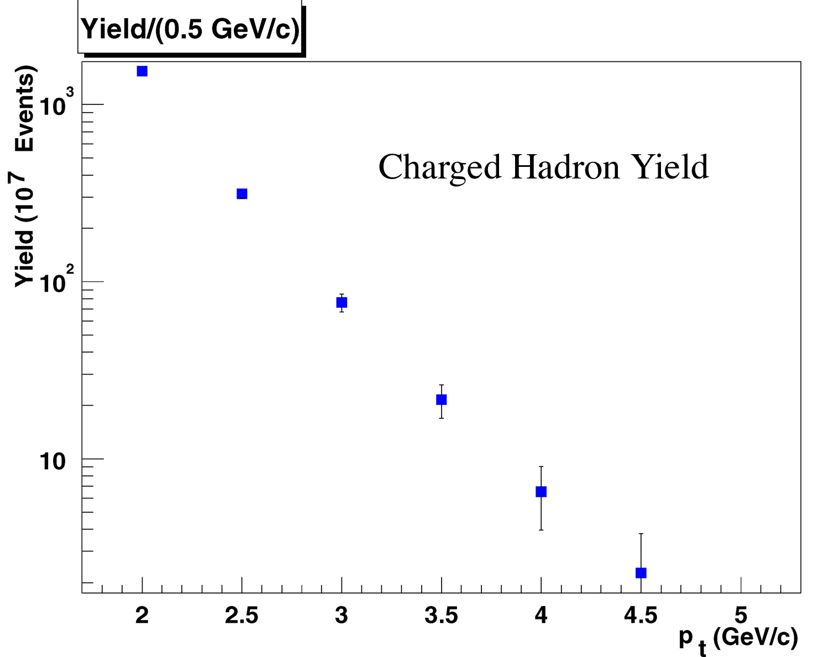
Fig. 8 — Calculated hadron spectrum for Au+Au scattering at 130 GeV. Yields are based on the PHENEX results and assume a total of 10⁷ central events.

References:

¹ X.-N. Wang and M. Gyulassy, Physical Review Letters 68, 1480 (1992).
² K. Adcox and S. S. Adler and N. N. Ajitanand, et al., Physical Review Letters 8705, 2301 (2001).
³ K. Adcox, S. S. Adler, N. N. Ajitanand, et al., Physical Review Letters 88, 022301 (2002).

